UNITED STATES

SECURITIES AND EXCHANGE COMMISSION

Washington, D.C. 20549

SCHEDULE 14A INFORMATION

Proxy Statement Pursuant to Section 14(a) of the

Securities Exchange Act of 1934

☑ Filed by the registrant ☐ Filed by a party other than the registrant
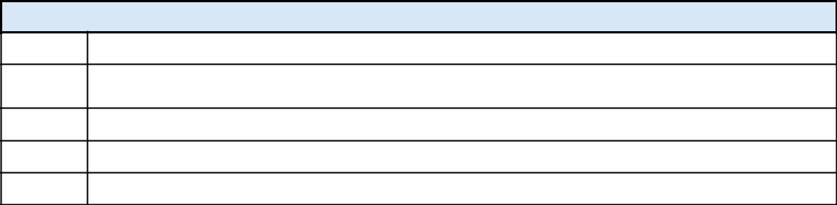

Check the appropriate box:

- Preliminary Proxy Statement

- CONFIDENTIAL, FOR USE OF THE COMMISSION ONLY (AS PERMITTED BY RULE 14A-6(E)
(2))

- Definitive Proxy Statement

- Definitive Additional Materials

- Soliciting Material Pursuant to Section 240.14a-12

AMGEN INC.

(Name of Registrant as Specified in Its Charter)

(Name of Person(s) Filing Proxy Statement, if other than the Registrant)
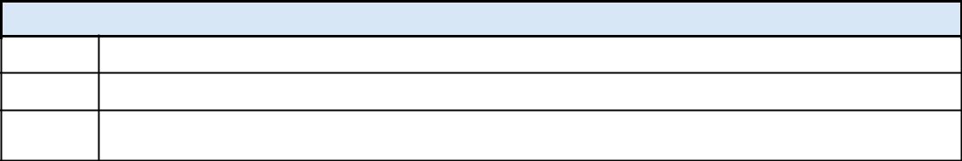

Payment of filing fee (check the appropriate box):

- No fee required.

- Fee paid previously with preliminary materials.

- Fee computed on table in exhibit required by Item 25(b) per Exchange Act Rules 14a-6(i)(1) and 0-11.

Subsequent to this filing, Amgen Inc. sent the following summary communication to one or more investors and/or proxy advisory firms for their consideration in making their vote recommendations.


Amgen 2026 Proxy Statement Key Highlights

2025 was another year of strong execution, with 10% year-over-year revenue and sales growth, 18 of our products achieving record sales, 14 products exceeding $1 billion in sales, and 13 products delivering double-digit sales growth. We also delivered on an ambitious research and development program agenda, including receiving five important U.S. Food and Drug Administration (FDA) regulatory approvals and advancing the MariTide (maridebart cafraglutide) Phase 3 program in obesity and obesity-related conditions.

Highlights for the year include:

- In General Medicine, our Phase 3 VESALIUS-CV study of Repatha® in patients at high cardiovascular (CV) risk without prior myocardial infarction or stroke showed that Repatha significantly reduced the risk of first major adverse CV events (by 25%) and first heart attack (by 36%), and data from real-world studies, including VESALIUS-REAL, provided real-world evidence supporting Repatha's use in low-density lipoprotein cholesterol (LDL-C) management. For MariTide, we initiated and advanced six global studies under our broad Phase 3 clinical development program across four obesity and obesity-related conditions (chronic weight management, CV outcomes, heart failure, and obstructive sleep apnea), highlighting the potential impact of MariTide beyond weight loss.

- In Oncology, IMDELLTRA® received full FDA approval for second-line or later treatment of adult patients with extensive-stage small cell lung cancer (ES-SCLC), demonstrating its survival advantage over standard-of-care chemotherapy. LUMAKRAS® (in combination with Vectibix®) received FDA approval for third-line treatment of KRAS G12C-mutated metastatic colorectal cancer.

- In Rare Disease, UPLIZNA® received two FDA approvals, including as the first and only treatment for adults living with Immunoglobulin G4-related disease (IgG4-RD) and as a treatment of generalized myasthenia gravis (gMG).

- In Inflammation, TEZSPIRE®⁽¹⁾ received FDA approval for the treatment of chronic rhinosinusitis with nasal polyps. Two Phase 3 studies have been initiated and are enrolling patients with moderate to very severe chronic obstructive pulmonary disease (COPD), one of the leading causes of death in the world.

Expansion of our State-of-the-Art Manufacturing and Research and Development Facilities: Following our 2024 announcement of a $1 billion expansion of our North Carolina facilities, we continued to expand our U.S. manufacturing network in 2025, announcing additional investments of $900 million in Ohio and $650 million in Puerto Rico, to support increased drug production and the integration of innovative advanced process development technologies that are designed to significantly increase our yields. These expansions reinforce our long-standing commitment to U.S.-based biomanufacturing and are designed to enhance the resilience and flexibility of our global supply network. In 2025, we also broke ground on a $600 million center for science and innovation in California focused on accelerating our discovery of innovative medicines addressing high unmet medical needs.

Our Commitment to Our Patients and Communities: Through the Amgen Safety Net Foundation (ASNF) and our corporate philanthropy, we assist eligible patients around the world in obtaining the medicines they need but cannot afford. Since 2001, ASNF has provided approximately $19 billion in commercial value of Amgen's medicines at no cost to uninsured or underinsured patients.⁽²⁾ Additionally, the science education programs funded by the Amgen Foundation have reached over 80 million students and teachers globally to date, helping to inspire the next generation of innovators.

- TEZSPIRE is being developed in collaboration with AstraZeneca plc.
- Valued at wholesale acquisition cost.
1

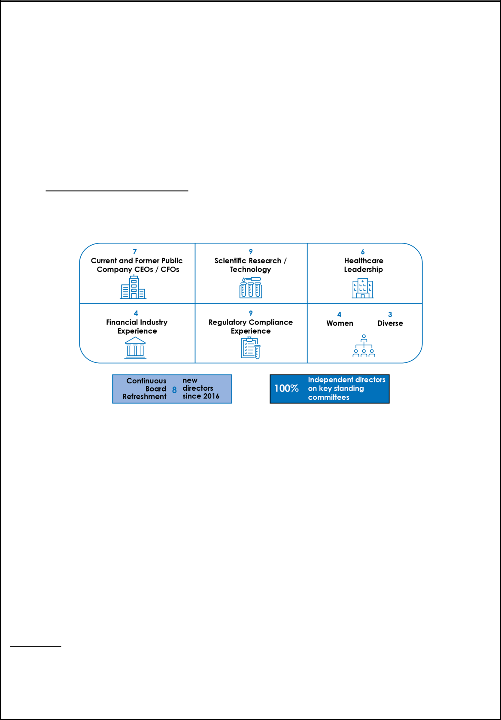
Voting Matters and Board Recommendations

We are sending this summary in support of Amgen’s Board of Directors’ recommendations for our

2026 Annual Meeting of Stockholders to be held on May 19, 2026.

FOR Each |  | Election of the 12 nominees to serve on our Board until the 2027 annual
Director | Item 1:
Director | Item 1: | meeting of stockholders.
Nominee |  | meeting of stockholders.
FOR | Item 2: | Advisory vote to approve our executive compensation.
FOR | Item 3: | Ratification of Ernst & Young LLP as our independent registered public
FOR | Item 3: | accountants.
AGAINST | Item 4: | Stockholder proposal to require an independent Board chair, if properly
AGAINST | Item 4: | presented at our Annual Meeting.

Item 1: Our Board recommends “FOR” the election of the 12 director nominees.

Our Board consists of a group of highly qualified leaders in their respective fields. Reflecting our Board’s commitment to refreshment, our Board has appointed eight new directors since 2016 and we have an average Board tenure of ~8 years.
Balanced Board Perspectives

- All of our director nominees have senior leadership experience at large organizations and have gained significant and wide-ranging management experience.

- Many of our director nominees also have public company experience, an understanding of corporate governance practices and trends, and bring unique perspectives to the Board.

- A number of our director nominees have extensive scientific and healthcare expertise relevant to our industry, including pioneering scientific research and experience leading important academic and healthcare institutions.

We are committed to corporate governance best practices overseen by our highly experienced and independent Board.

  - We have a highly independent Board (11 of our 12 director nominees are independent) and only independent Board members serve on our key standing committees.⁽¹⁾

  - Our lead independent director, Robert A. Eckert, has specific and significant duties and has been elected by our Board to serve as the lead independent director in 2026, subject to his re-election to the Board by stockholders.

  - A director serving as our CEO should not serve on more than two outside public company boards and no director should serve on more than five public company boards. As part of its nominating process, the Governance and Nominating Committee conducts an annual review of director commitment levels and shares its findings with the Board. Currently, our CEO serves on one outside public company board and no director serves on more than two outside public company boards.

- Key standing committees of the Board include the Audit, Compensation and Management Development, Corporate Responsibility and Compliance, and Governance and Nominating Committees.

2


We have a long-standing practice of stockholder engagement and our Board has a history of responsiveness to stockholder feedback.

- We have a long-standing practice of stockholder engagement throughout the year and at our Annual Meeting. Consistent with prior years’ practices, since our 2025 annual meeting of stockholders, we have engaged in governance-focused outreach activities and discussions with stockholders holding approximately 59% of our outstanding shares.

- In addition to our stockholders electing our Board annually by majority voting and having rights to act by special meeting, written consent, and proxy access, as well as our robust recoupment mechanisms, informed by discussions with our stockholders, we have expanded and enhanced a number of our disclosures and implemented other changes, including with respect to our: alignment of compensation program with strategic priorities; drug pricing practices; patents for our five top selling products; tax strategy reporting; oversight of political contributions, memberships in trade and industry associations, and lobbying; and corporate philanthropy program.

Item 2: Our Board recommends “FOR” the advisory vote to approve executive compensation.

We have implemented compensation best practices, including:

- Our equity incentive plan provides that our equity awards are subject to a minimum vesting period of no less than one year for 95% of equity awards granted, with most equity grants vesting over four years to emphasize the long-term performance focus of our LTI equity award program and enhance retention.

- We have robust stock ownership and retention guidelines.

- We have a clawback policy providing for the mandatory recovery from our Section 16 officers, including our NEOs, of erroneously awarded incentive-based executive compensation, including past annual cash incentive awards and performance unit payouts granted, earned, or vested, wholly or in part, upon the attainment of any financial reporting measure that is the subject of a financial restatement.⁽¹⁾

- We also have strong recoupment provisions that permit a determination that annual cash incentive awards are not earned as a result of misconduct and to facilitate the forfeiture and cancellation of unvested or unexercised equity awards.⁽²⁾

Executive compensation is aligned with our business strategy and is performance-based.

    - We pay for performance with a mix of incentives and targets (financial and operational) and pay outcomes reflect the achievements of our NEOs against our near- and long-term performance.

  - Our Compensation and Management Development Committee approves annual Company goals that are designed to focus our NEOs and all of our staff members on delivering our financial and operational objectives to drive annual performance, advance strategic priorities, and position us for longer-term success.

  - Our annual long-term incentive equity awards are primarily performance-based with 50% of award value in the form of three-year performance units and 30% in the form of stock options that vest over four years.

  - 76% of our CEO’s 2025 target direct compensation and 70% of our other NEOs’ target direct compensation was based solely on our Company’s performance.
  - 92% of our CEO’s 2025 target direct compensation and 83% of our other NEOs’ target direct compensation was "at-risk."

- Our clawback policy is available on our website at https://wwwext.amgen.com/about/how-we-operate/ corporate-governance/amgen-policy-on-recovery-of-erroneously-awarded-compensation and incorporated by reference as Exhibit 97 to our Annual Report on Form 10-K for the year ended December 31, 2025. Reference to our website is not intended to function as a hyperlink and the information contained on our website is not intended to be part of this document.

- Granted after December 31, 2020.
3


Item 3: Our Board recommends “FOR” the ratification of the selection of Ernst & Young LLP as our independent registered public accountants.

Our Audit Committee periodically considers whether there should be a rotation of our independent registered public accountants. Each year, the Audit Committee evaluates the qualifications and performance of the independent registered public accountants and determines after such evaluation whether to re-engage the current independent registered public accountants. Based on this evaluation, the Audit Committee believes that the continued retention of our independent registered public accountants is in the best interests of the Company and its stockholders.

Item 4: Our Board recommends “AGAINST” the stockholder proposal to require an independent Board chair.

We are opposing the stockholder proposal to require an independent Board chair for the following reasons:

- Independent Oversight. Our Company has numerous mechanisms that ensure independent oversight of the Company's affairs and that facilitate communication with, and an independent evaluation of, senior management.

- Leadership Structure. Our governance documents give the Board discretion in determining whether to separate or combine the roles of the Chairman and CEO. This flexibility permits the Board to choose a leadership structure that can be tailored to the strengths of the Company's officers and directors at the time and to best address our evolving and highly complex business.

- Annual Evaluation of Leadership Structure. The Board conducts annual evaluations of the Company's leadership structure and determined that the Company and its stockholders are best served at this time by having Robert A. Bradway serve as both Chairman and CEO, coupled with a separate active lead independent director, currently held by Robert A. Eckert.

- Active Experienced Lead Independent Director with Robust Responsibilities. We have an active lead independent director elected annually by and from the independent directors and strong Board and committee involvement to provide sound and robust oversight of management. The responsibilities of the lead independent director are well defined and the lead independent director engages in regular communication with the other independent directors, including in independent directors sessions.

- Strong 2025 Performance Under the Board's Leadership Structure. In 2025, despite the external headwinds cited in the stockholder proposal as a rationale for changing the Board's leadership structure, the Company delivered strong performance and robust financial results, including 10% year-over-year revenue and sales growth, and made meaningful progress on our strategic priorities, including advancing our innovative pipeline and securing five U.S. Food and Drug Administration approvals. Our strong cash flows and balance sheet in 2025 allowed us to make significant investments for long-term growth, including investing approximately $7 billion in research and development and $2 billion in strategic capital projects, while also reducing our debt outstanding by $6 billion and returning $5 billion of capital to our stockholders in dividends. Our performance in 2025 demonstrated the effectiveness of our Board leadership structure and its oversight of the Company's strategy and execution.

- Commitment to Stockholder Rights. We maintain meaningful stockholder rights and regularly review our corporate governance practices with the Board in light of investor feedback and evolving market practices. These stockholder rights include a single class of shares with equal voting rights, proxy access, action by written consent, the right to call special meetings, no supermajority vote provisions, and no poison pill.

For the reasons stated above and in the Board response to the stockholder proposal in our proxy statement, our Board strongly and unanimously recommends that you vote "AGAINST" the stockholder proposal.

Our 2026 Annual Meeting of Stockholders will be held solely by remote communication via the internet. Although the meeting will not be held in person, stockholders will, to the extent possible, be afforded the same rights and opportunities to participate at the virtual meeting similarly to how they would participate at an in-person meeting. Stockholders will have a meaningful opportunity to ask questions.

4

