UNITED STATES
SECURITIES AND EXCHANGE COMMISSION
Washington, D.C. 20549
SCHEDULE 14A INFORMATION
Proxy Statement Pursuant to Section 14(a) of the
Securities Exchange Act of 1934
☑ Filed by the registrant | ☐ Filed by a party other than the registrant
Check the appropriate box:

☐ | Preliminary Proxy Statement
☐ | CONFIDENTIAL, FOR USE OF THE COMMISSION ONLY (AS PERMITTED BY RULE 14A-6(E)(2))
☐ | Definitive Proxy Statement
☑ | Definitive Additional Materials
☐ | Soliciting Material Pursuant to Section 240.14a-12

AMGEN INC.
(Name of Registrant as Specified in Its Charter)
(Name of Person(s) Filing Proxy Statement, if other than the Registrant)
Payment of filing fee (check the appropriate box):

☑ | No fee required.
☐ | Fee paid previously with preliminary materials.
☐ | Fee computed on table in exhibit required by Item 25(b) per Exchange Act Rules 14a-6(i)(1) and 0-11.

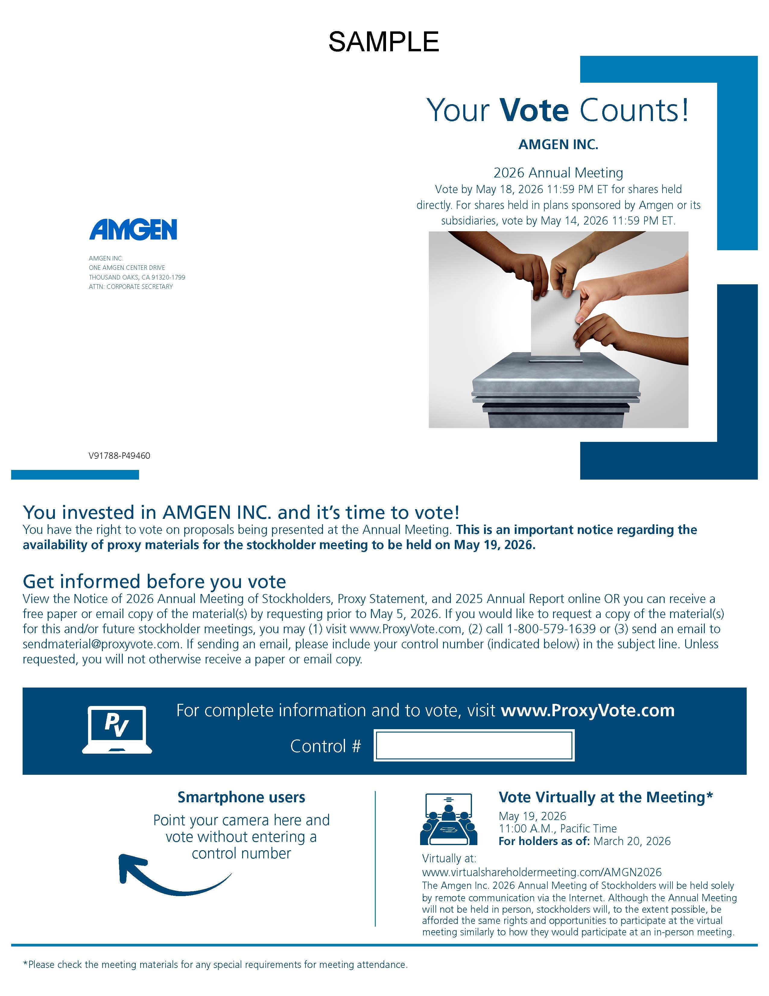

Sample Your Vote Counts! AMGEN INC. 2026 Annual Meeting Vote by May 18, 2026 11:59 PM ET for shares held directly. For shares held in plans sponsored by Amgen or its subsidiaries, vote by May 14, 2026 11:59 PM ET. AMGEN INC. ONE AMGEN CENTER DRIVE THOUSAND OAKS, CA 91320-1799 ATTN: CORPORATE SECRETARY V91788-P49460 You invested in AMGEN INC. and it’s time to vote! You have the right to vote on proposals being presented at the Annual Meeting. This is an important notice regarding the availability of proxy materials for the stockholder meeting to be held on May 19, 2026. Get informed before you vote View the Notice of 2026 Annual Meeting of Stockholders, Proxy Statement, and 2025 Annual Report online OR you can receive a free paper or email copy of the material(s) by requesting prior to May 5, 2026. If you would like to request a copy of the material(s) for this and/or future stockholder meetings, you may (1) visit www.ProxyVote.com, (2) call 1-800-579-1639 or (3) send an email to sendmaterial@proxyvote.com. If sending an email, please include your control number (indicated below) in the subject line. Unless requested, you will not otherwise receive a paper or email copy. For complete information and to vote, visit www.ProxyVote.com Control # Smartphone users Point your camera here and vote without entering a control number Vote Virtually at the Meeting* May 19, 2026 11:00 A.M., Pacific Time For holders as of: March 20, 2026 Virtually at: www.virtualshareholdermeeting.com/AMGN2026 The Amgen Inc. 2026 Annual Meeting of Stockholders will be held solely by remote communication via the Internet. Although the Annual Meeting will not be held in person, stockholders will, to the extent possible, be afforded the same rights and opportunities to participate at the virtual meeting similarly to how they would participate at an in-person meeting. *Please check the meeting materials for any special requirements for meeting attendance.

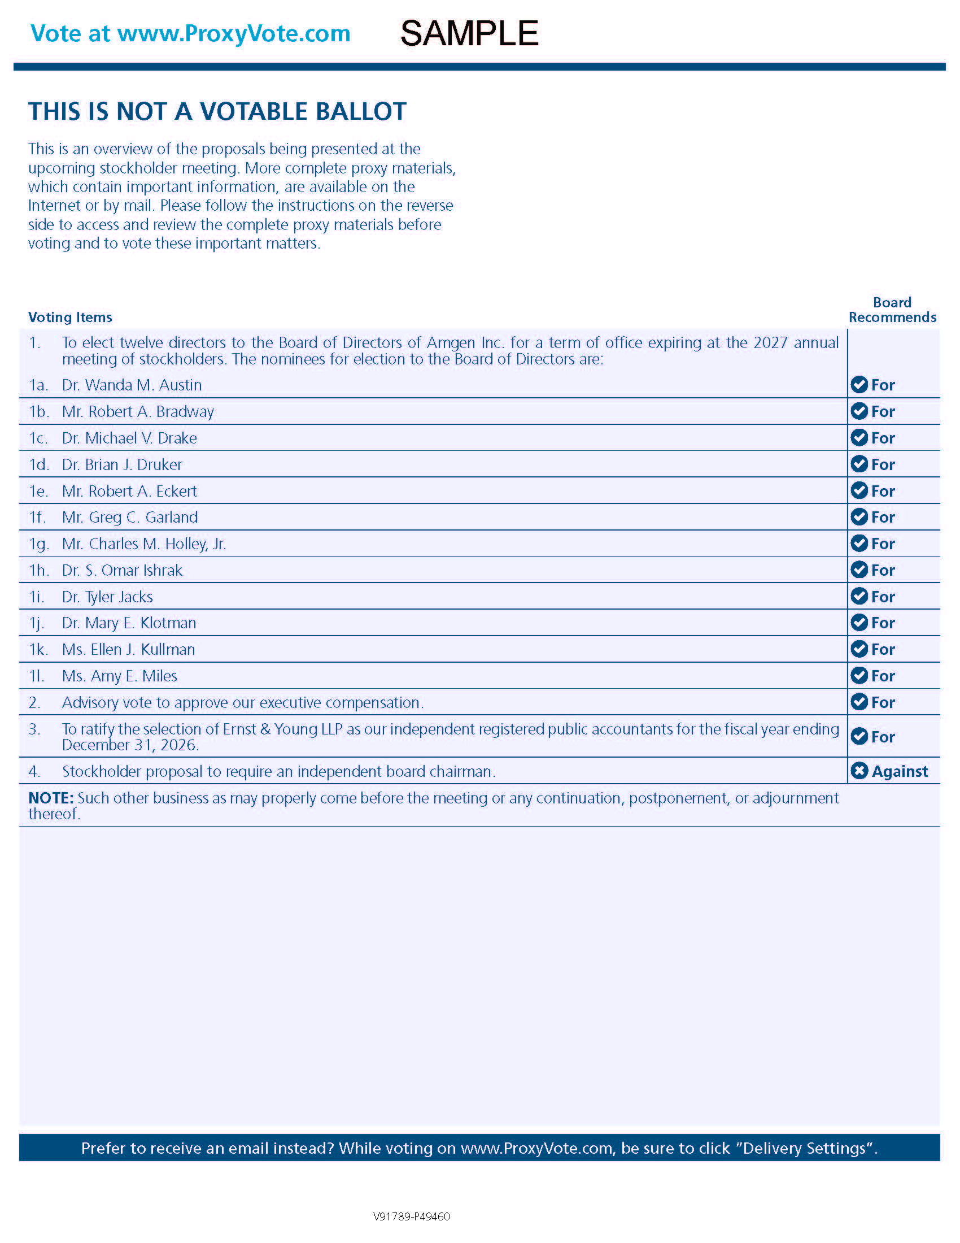

Sample Vote at www.ProxyVote.com THIS IS NOT A VOTABLE BALLOT This is an overview of the proposals being presented at the upcoming stockholder meeting. More complete proxy materials, which contain important information, are available on the Internet or by mail. Please follow the instructions on the reverse side to access and review the complete proxy materials before voting and to vote these important matters. Board Voting Items Recommends 1.To elect twelve directors to the Board of Directors of Amgen Inc. for a term of office expiring at the 2027 annual meeting of stockholders. The nominees for election to the Board of Directors are: 1a.Dr. Wanda M. AustinFor1b.Mr. Robert A. BradwayFor1c.Dr. Michael V. DrakeFor1d.Dr. Brian J. DrukerFor1e.Mr. Robert A. EckertFor1f.Mr. Greg C. GarlandFor1g.Mr. Charles M. Holley, Jr.For1h.Dr. S. Omar IshrakFor1i.Dr. Tyler JacksFor1j.Dr. Mary E. KlotmanFor1k.Ms. Ellen J. KullmanFor1l.Ms. Amy E. MilesFor2.Advisory vote to approve our executive compensation.For3.To ratify the selection of Ernst & Young LLP as our independent registered public accountants for the fiscal year ending December 31, 2026.For4.Stockholder proposal to require an independent board chairman. Against NOTE: Such other business as may properly come before the meeting or any continuation, postponement, or adjournment thereof. Prefer to receive an email instead? While voting on www.ProxyVote.com, be sure to click “Delivery Settings”. V91789-P49460

